WS 2025/26

Lab course: Human Robot Interaction

Task 1: Task 2: ROS Introduction, Kinematics and Interaction

Chair of Autonomous Systems and Mechatronics
Friedrich-Alexander-Universität Erlangen-Nürnberg

TEAM 1 :
Velayudhan Aravindakshan - ju08rufe
Akhilan David Karthikeyan - ug39owys
Wei Zhang - jo07wuwe

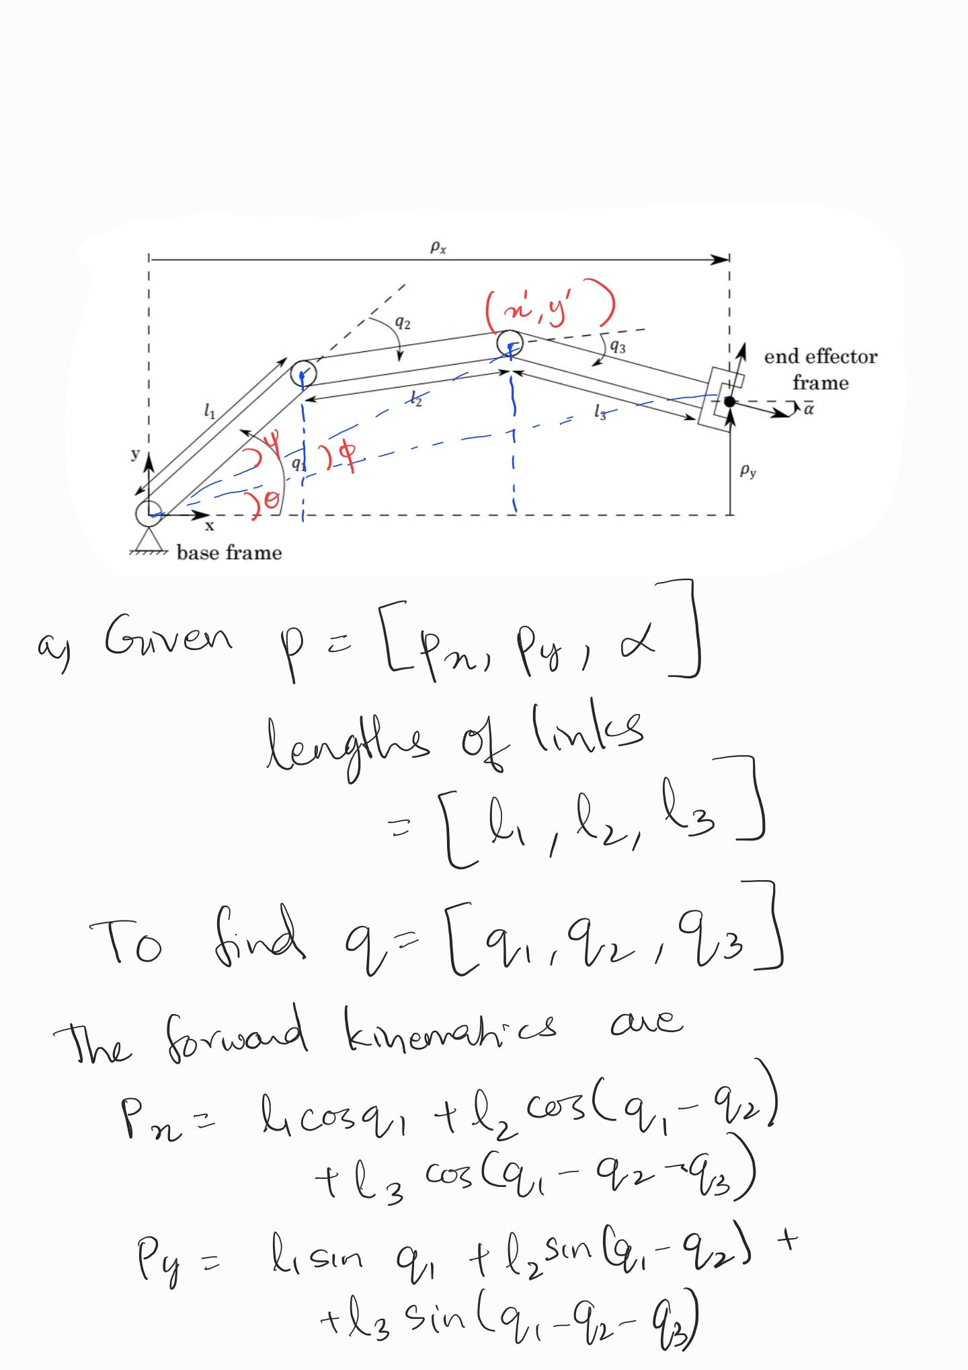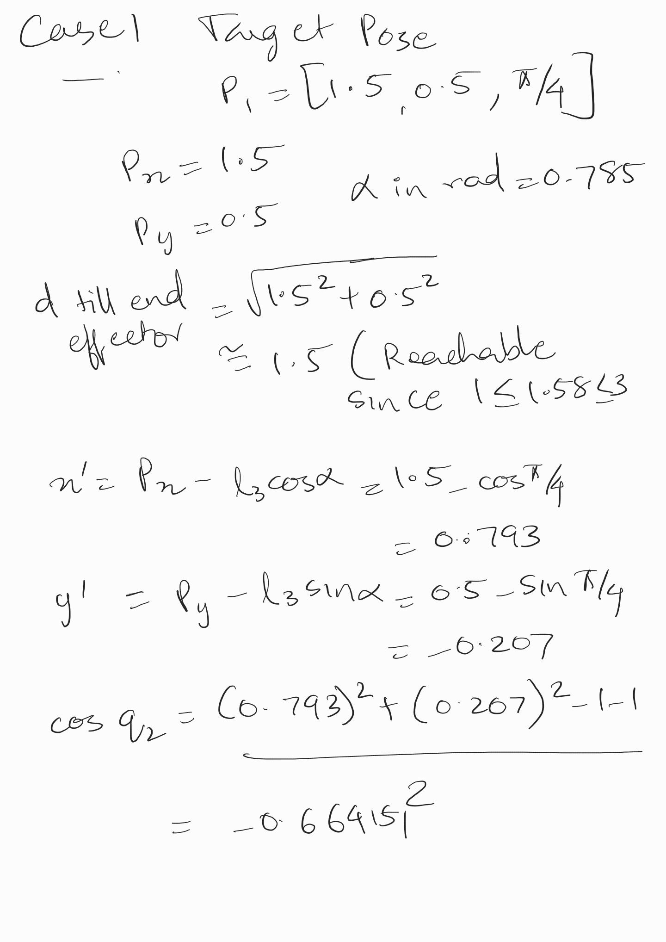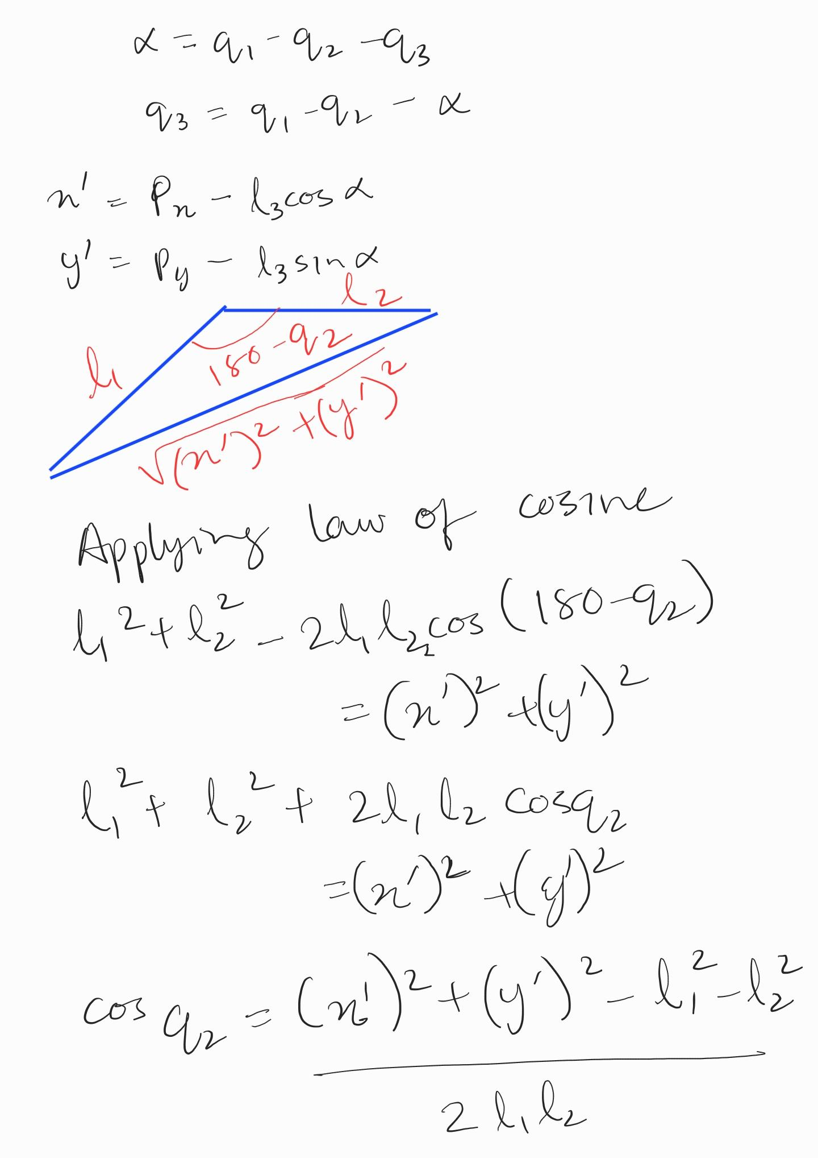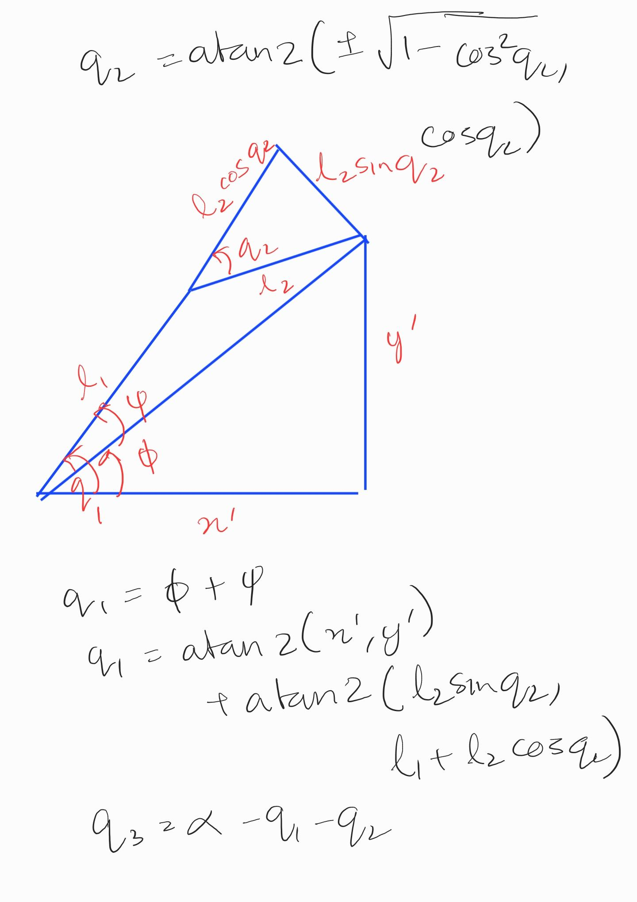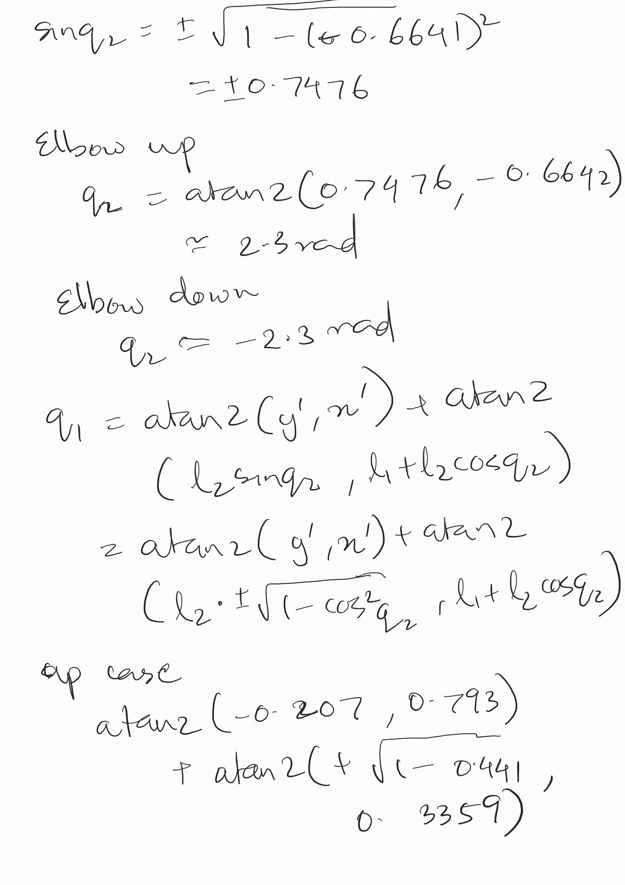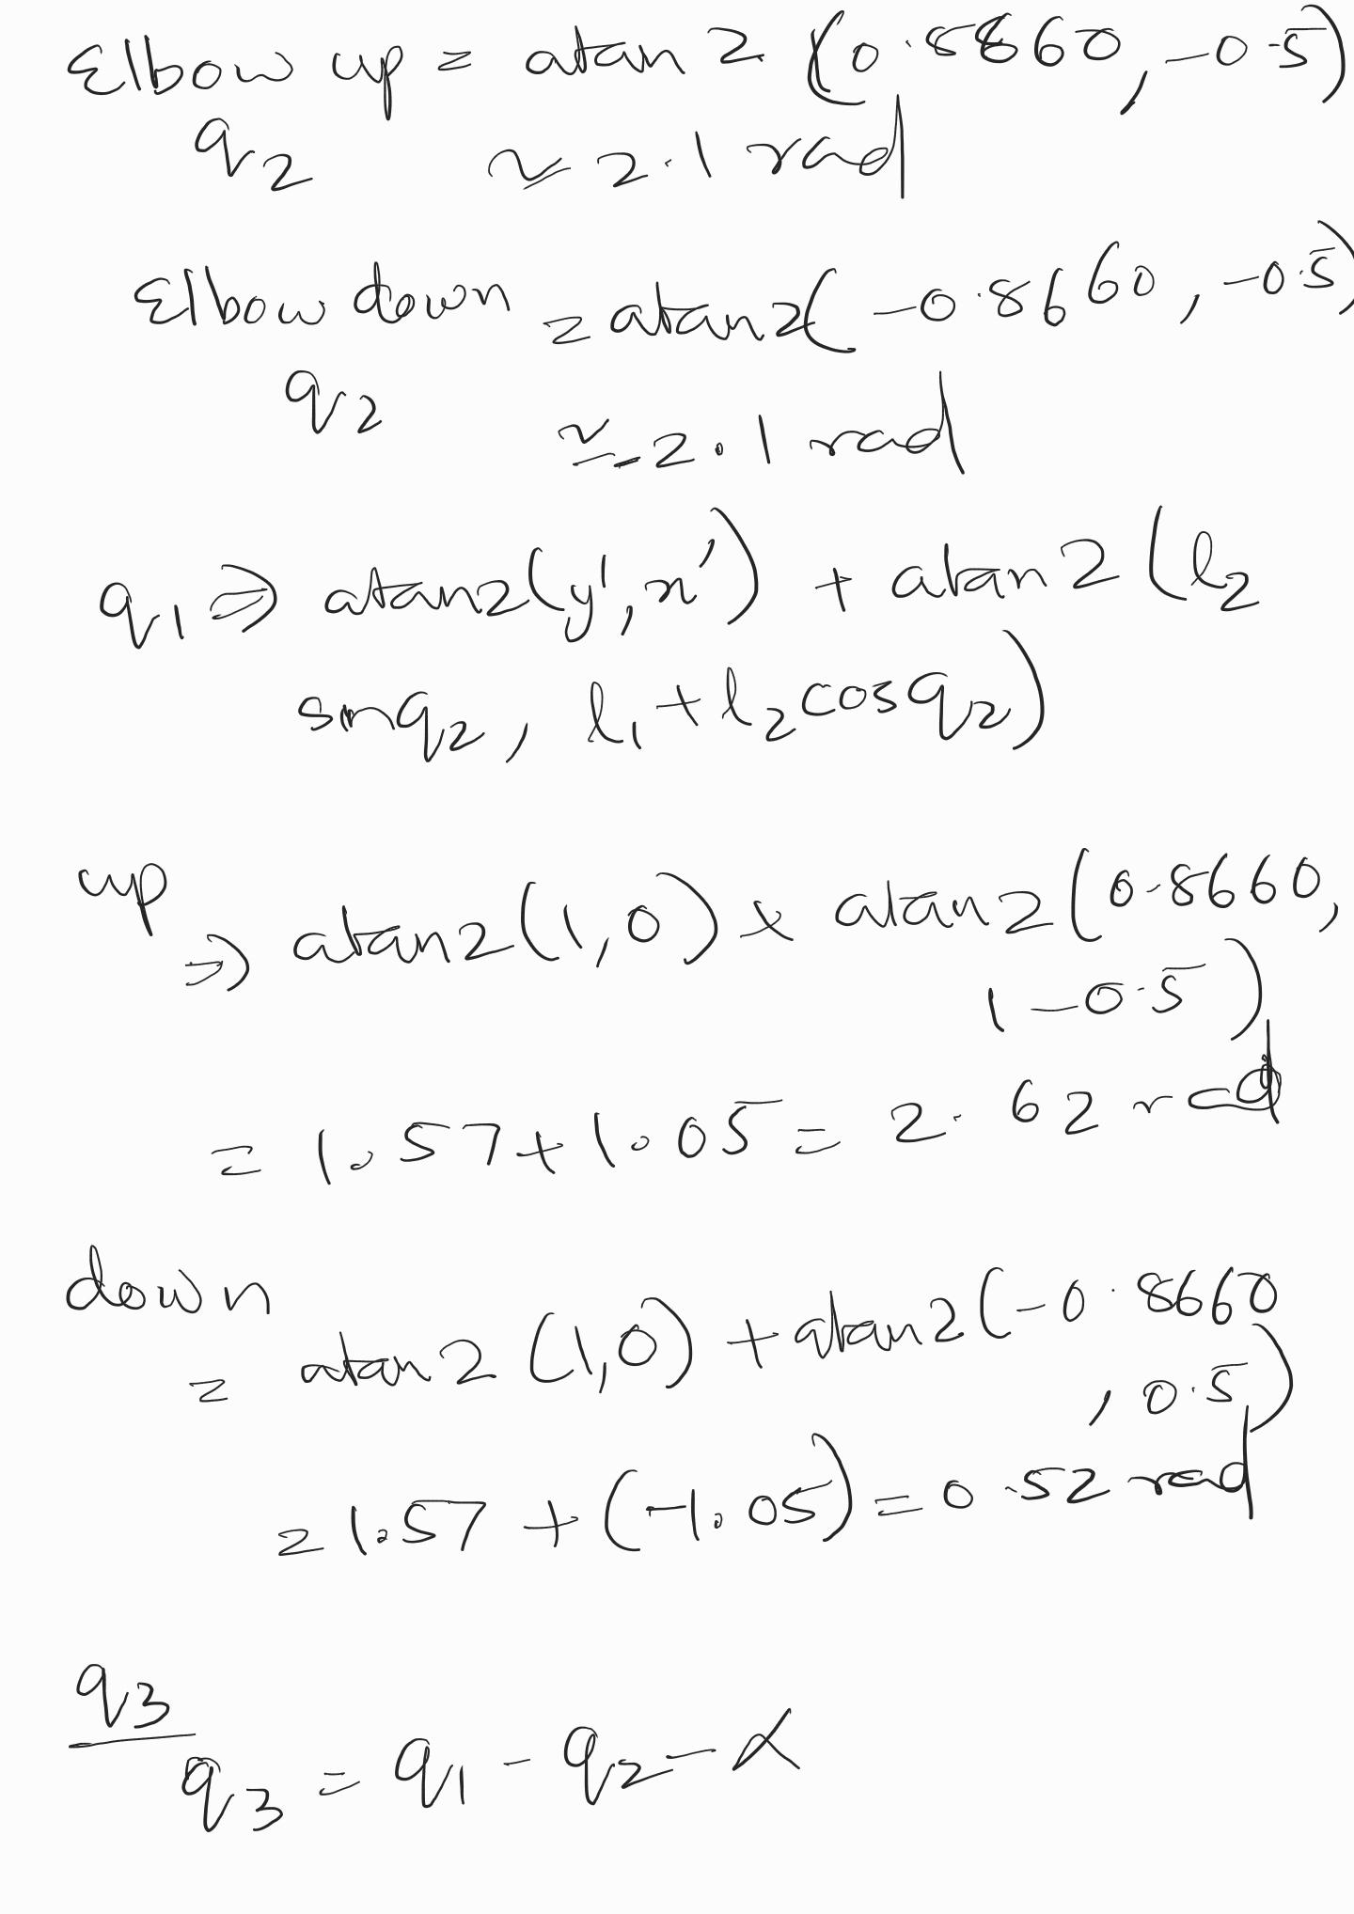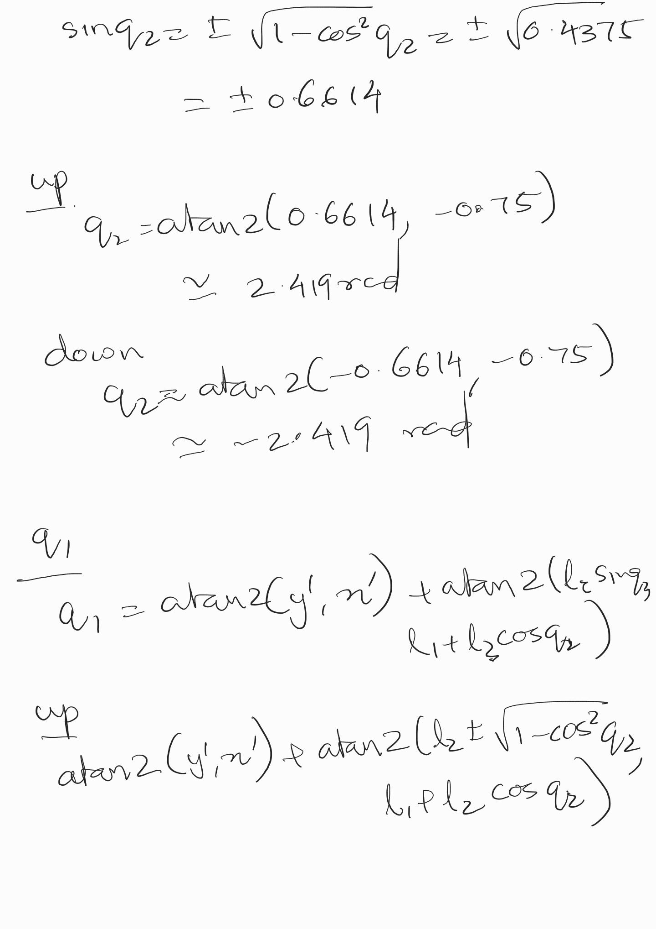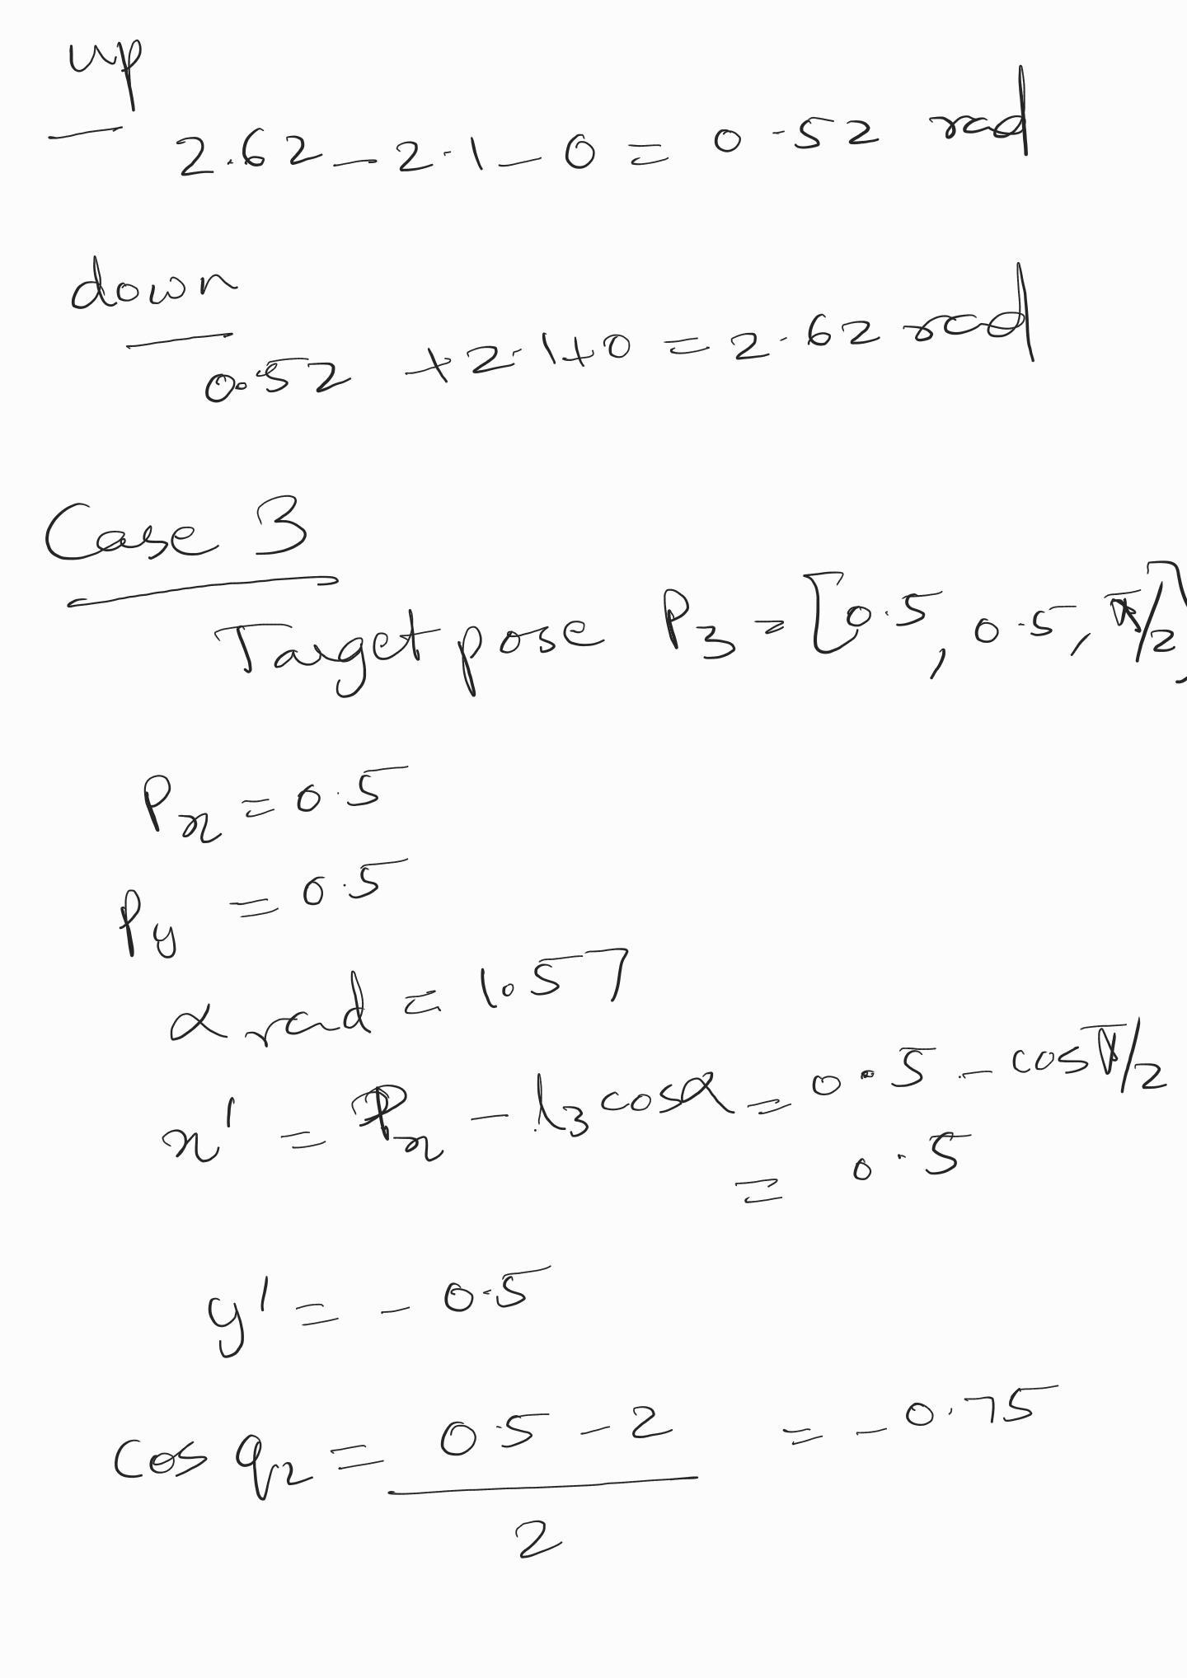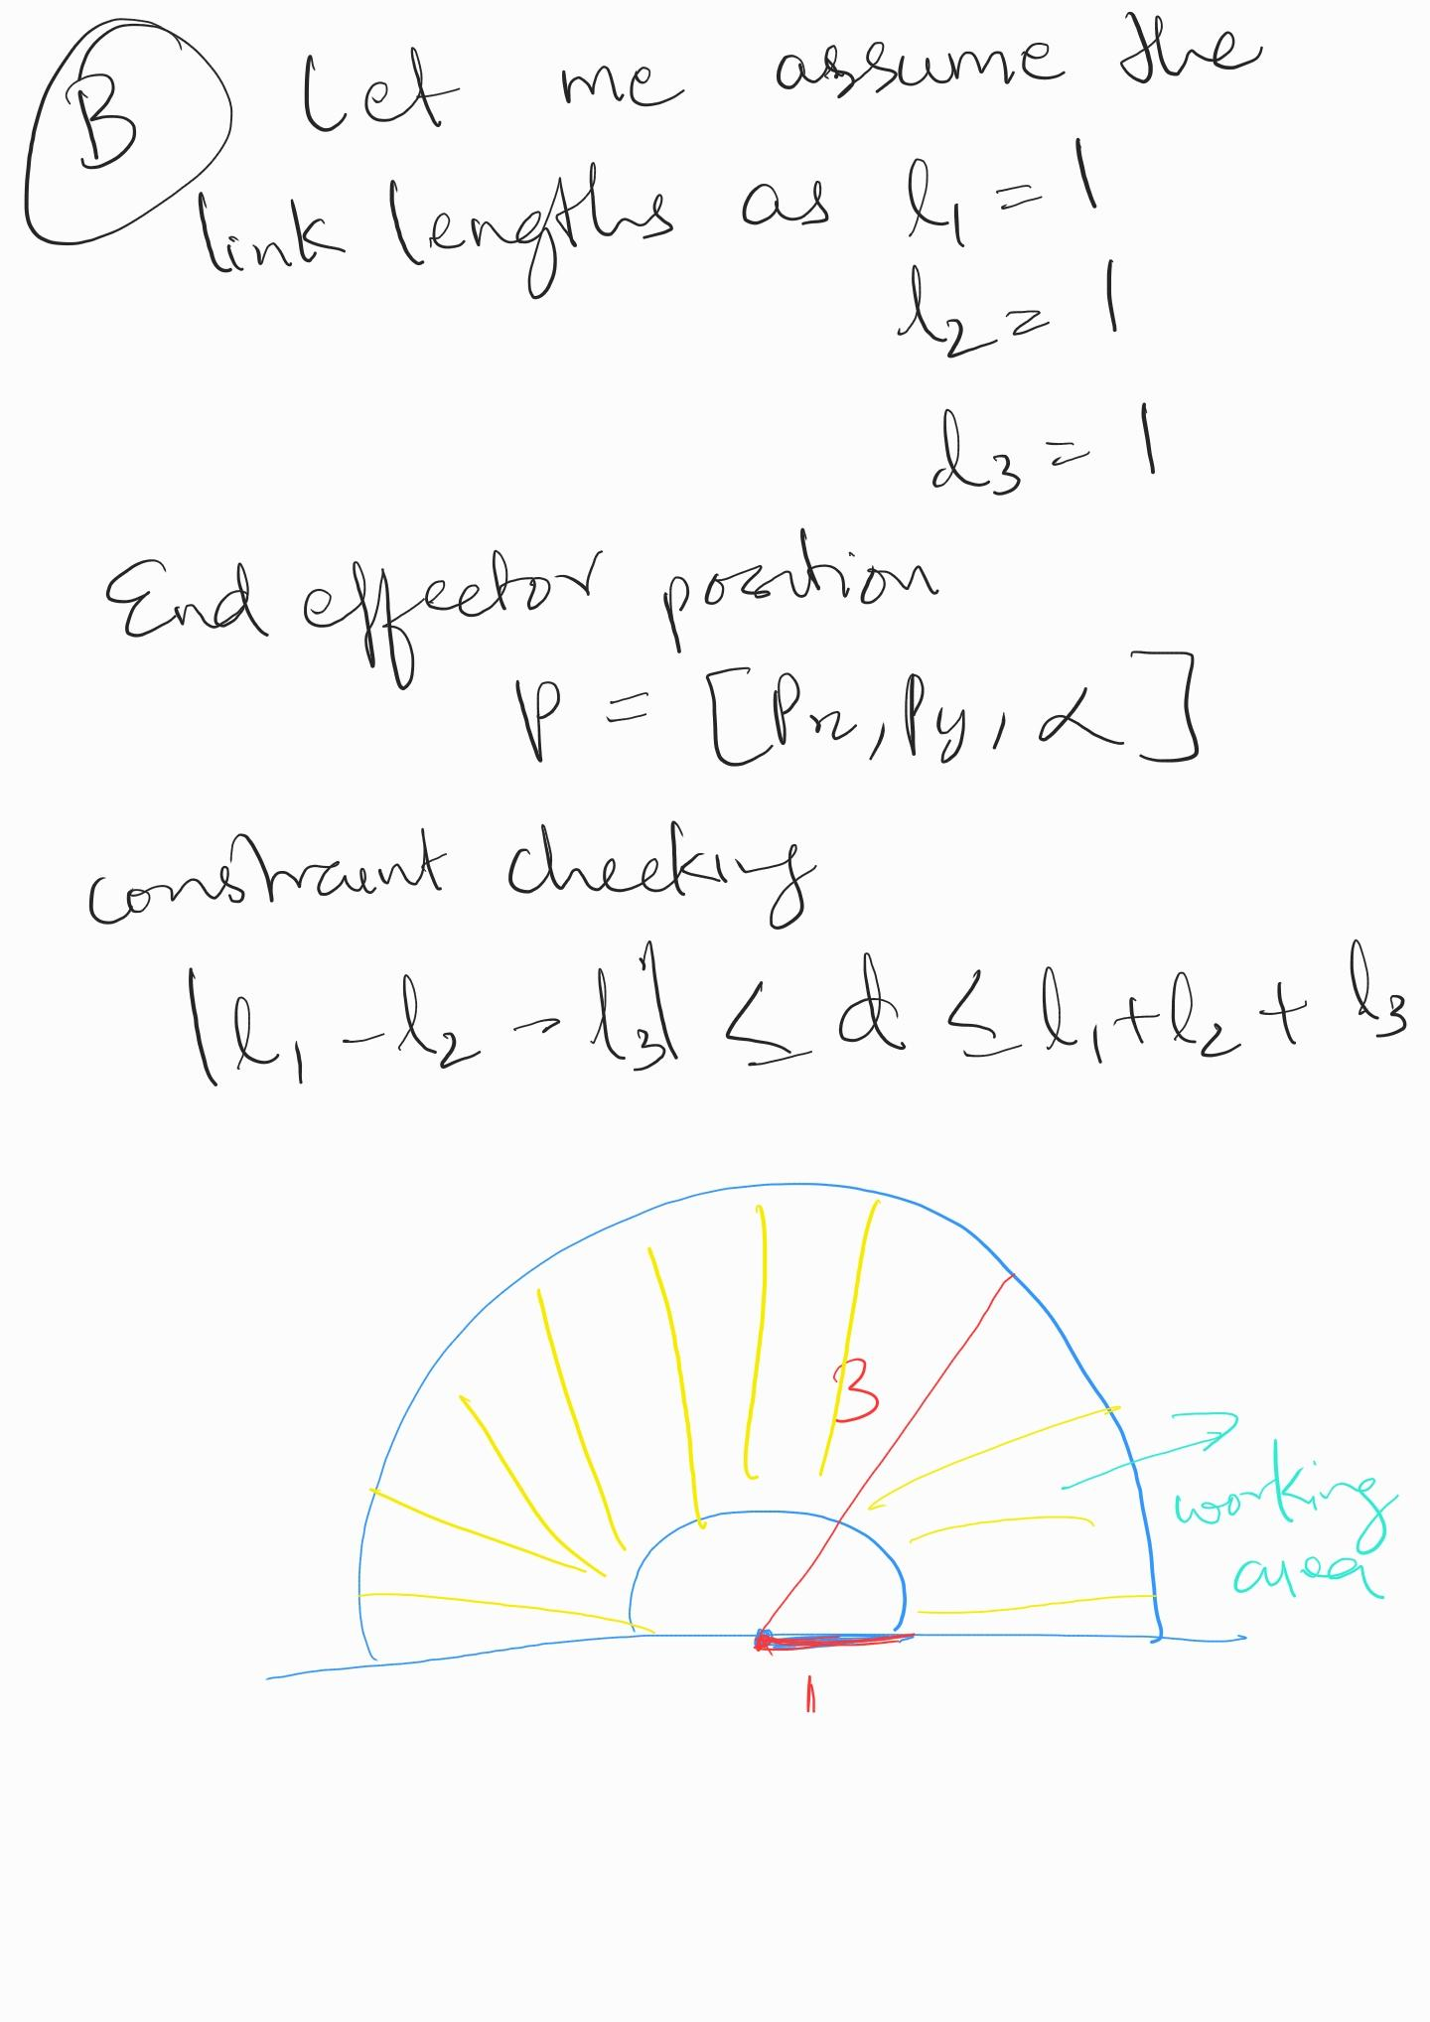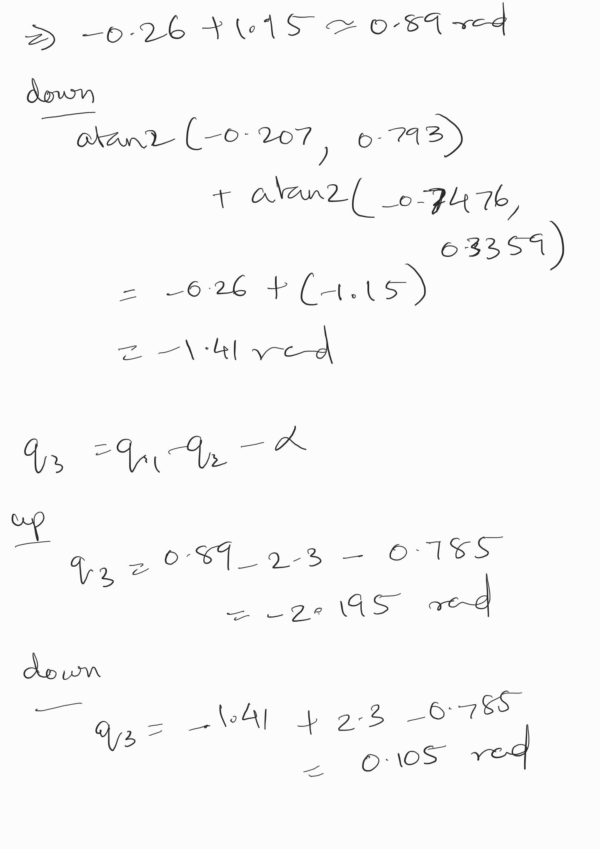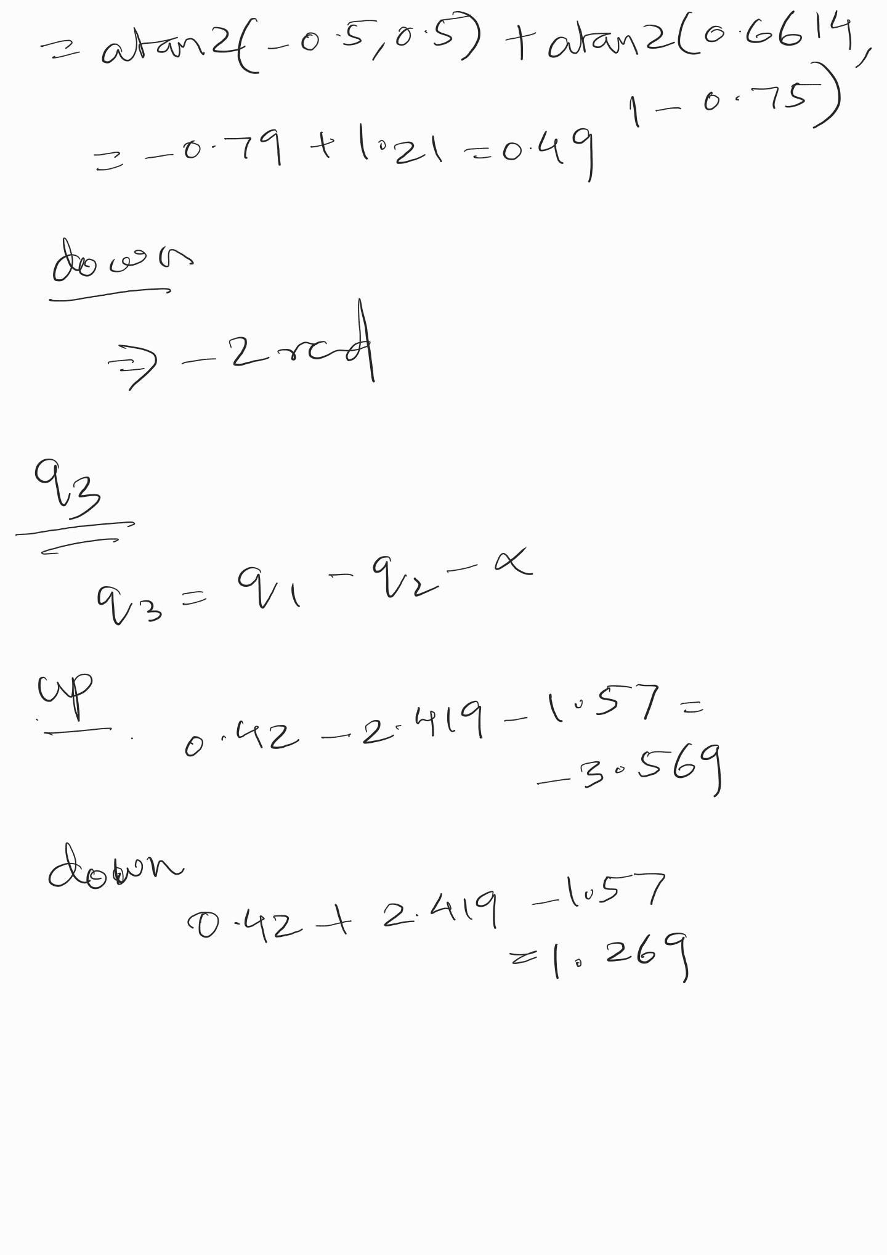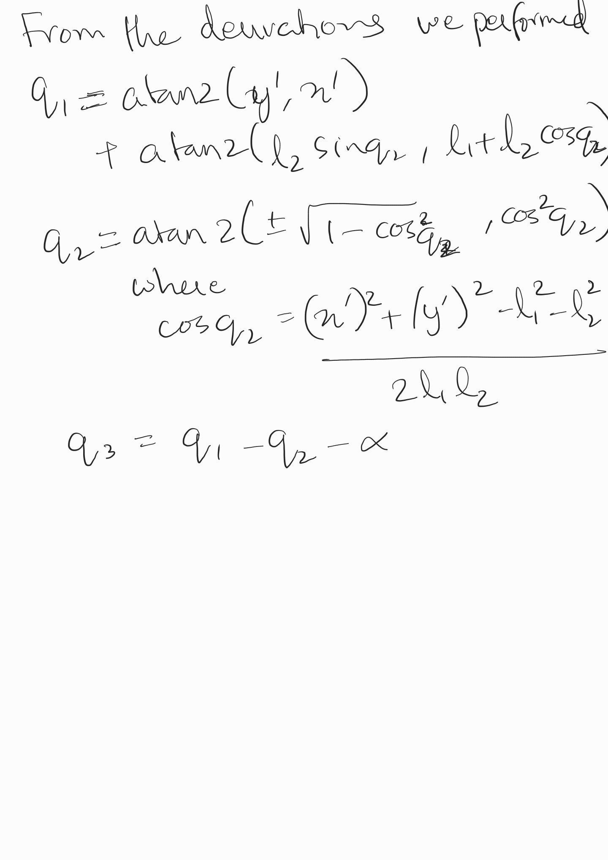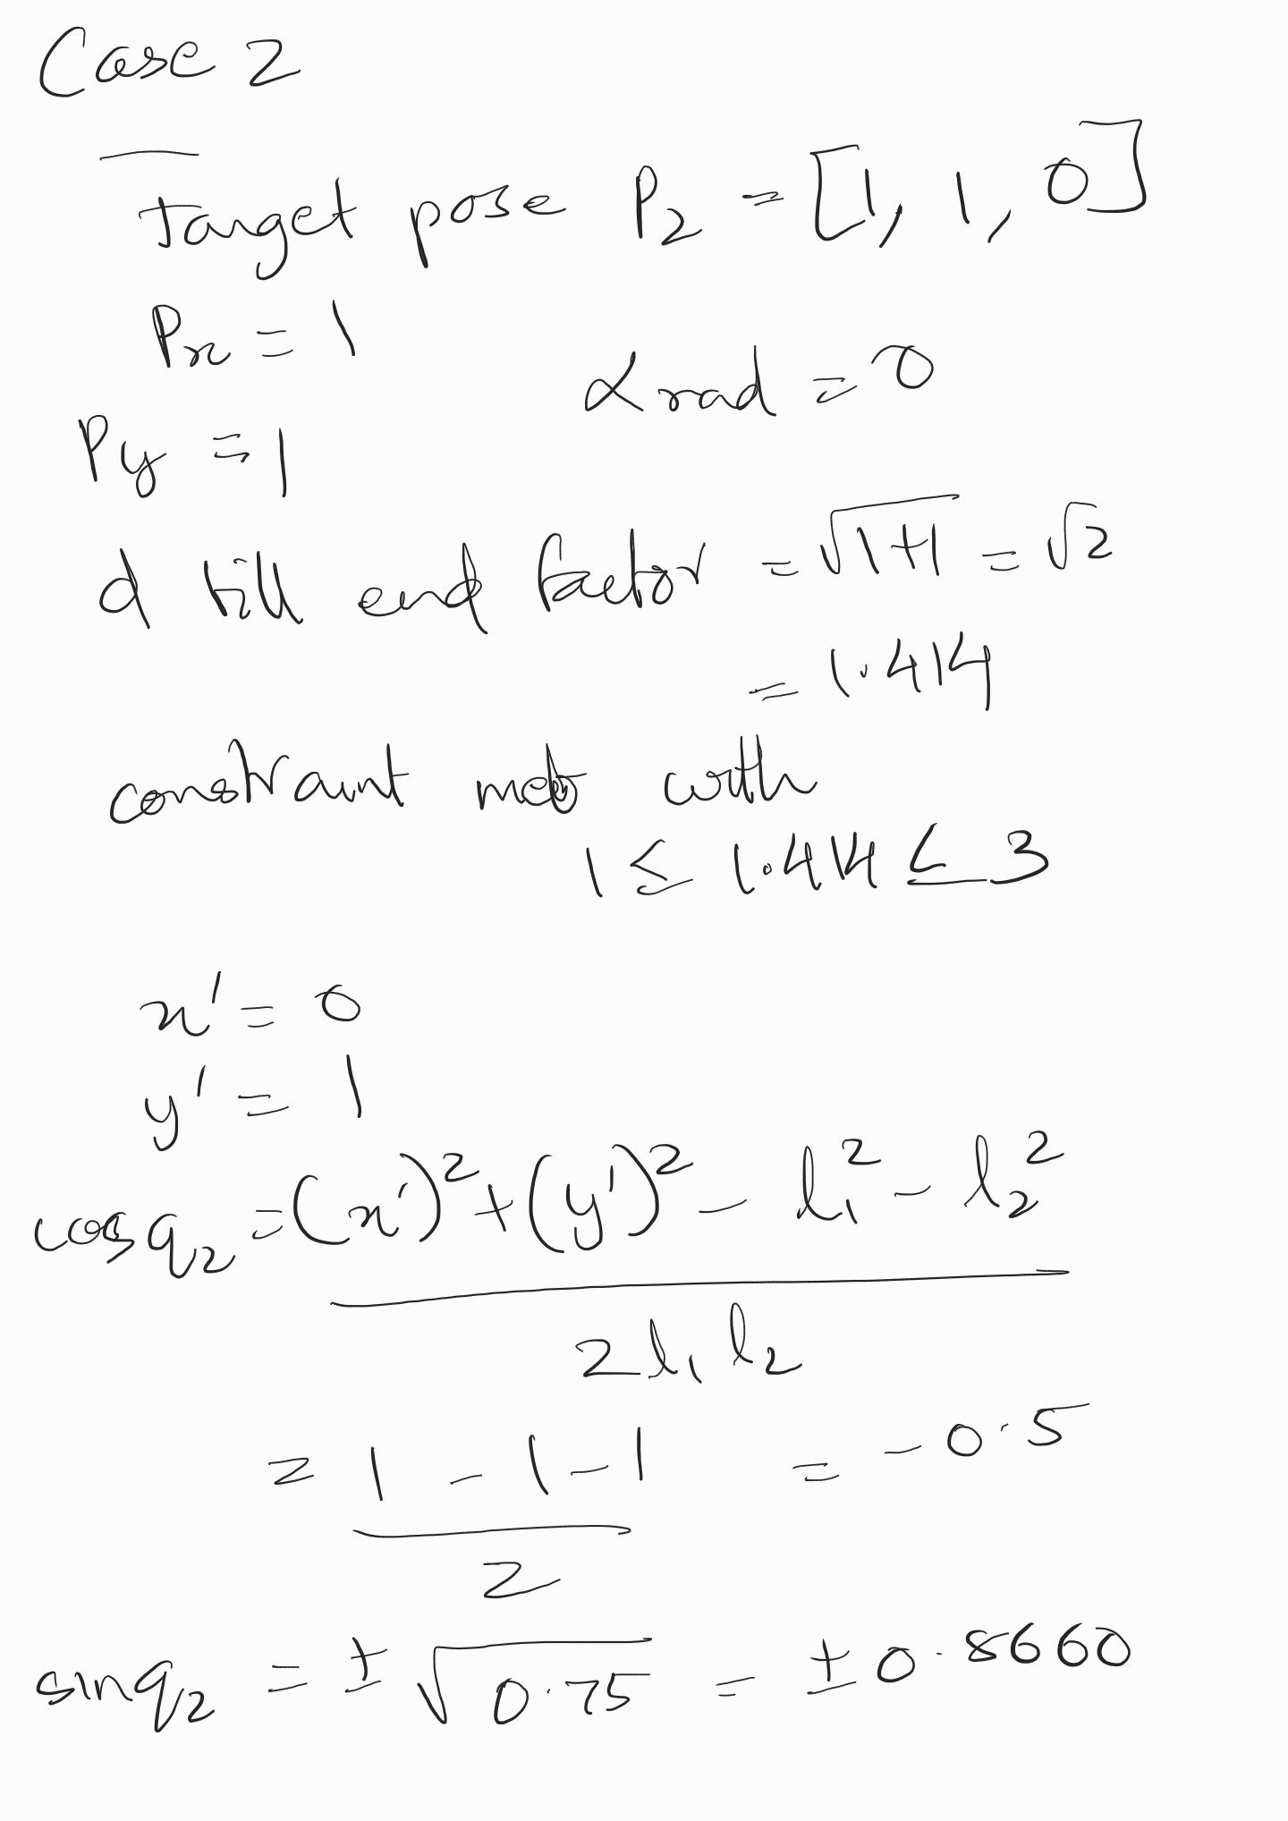

C. The significant issue consists of the non-uniqueness of the solution. For a given end effector position, there may be multiple sets of joint angles that can achieve the same position. Another issue involves the resulting singularities in the degree of freedom.

Exercise 2

1. Where Publishers and Subscribers are Defined?
They are defined in the main execution block(__main__) of the script.
The code first initialises the ROS node: rospy.init
The pub and sub are created after the node is initialised.

2. How the Publisher Accesses Subscriber Data?
The publisher accesses the data read and processed by the subscriber through global variables

Global Variables: Variables such as p, px, py, pa, q, and q_in_degrees are established outside of any function at the beginning of the script, rendering them global.

Subscriber Callback: The callback(msg) function utilises the global keyword to access and store the received Cartesian position data (msg.data) in the global variables (p, px, py, pa). Additionally, it computes the joint angles and records the outcomes in the global variables q and q_in_degrees.

Publisher Function: The pub_joint_angle() function (which encompasses the ROS loop) can subsequently read the joint angle data directly from the global variable q to disseminate the message.

The object-oriented methodology eliminates the necessity for global variables by defining them within the class's scope, allowing any class method (including callbacks and run loops) to access them via the self keyword.

Exercise 3

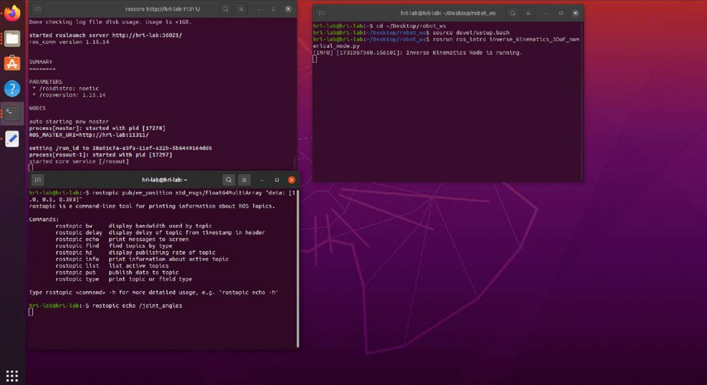

Exercise 4
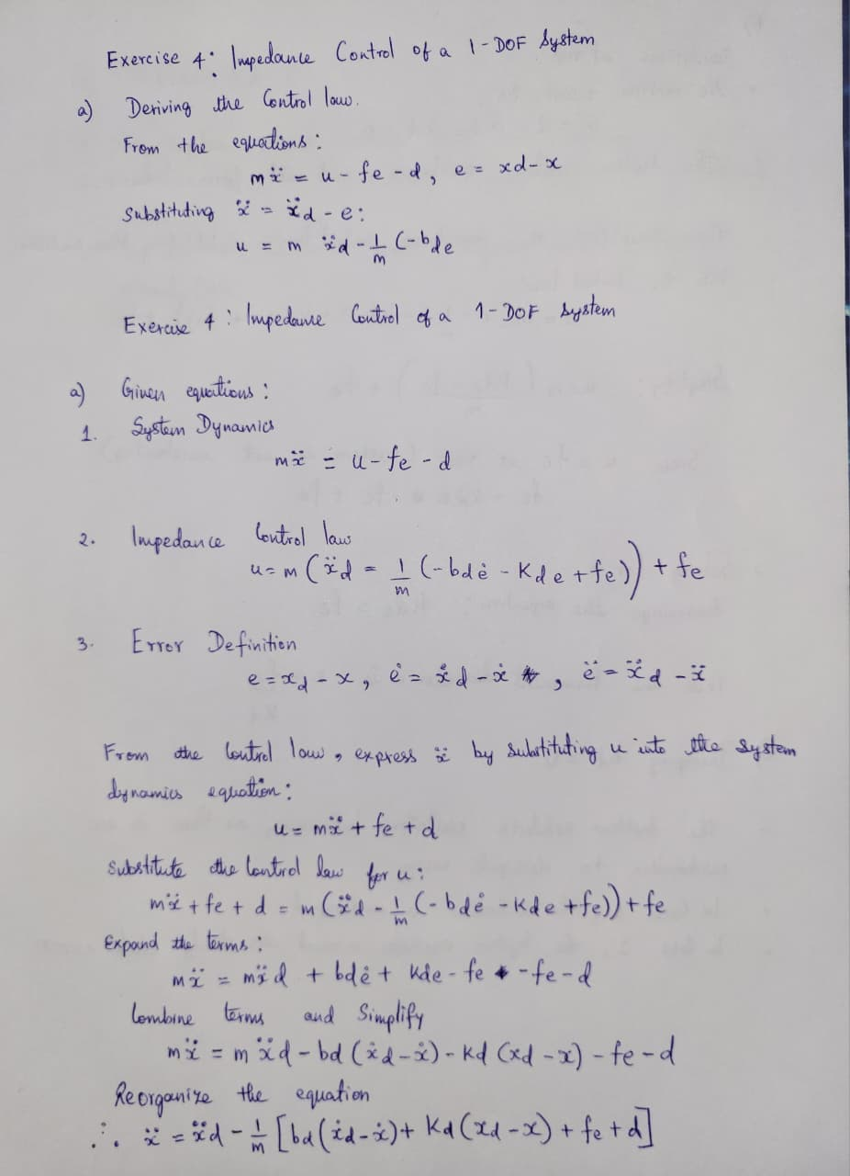

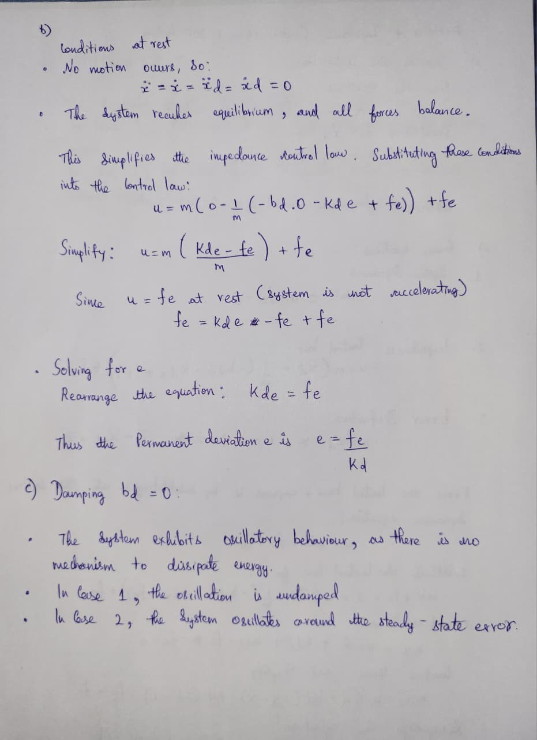

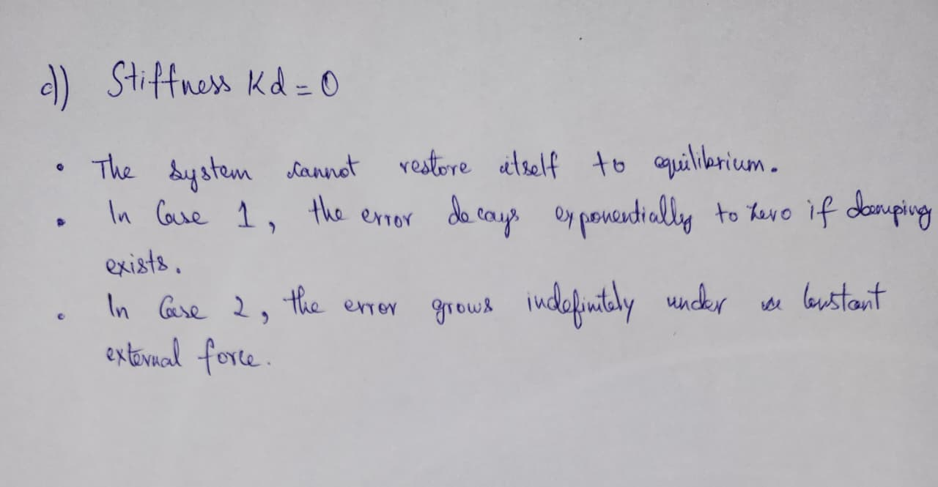

Exercise 5

a)
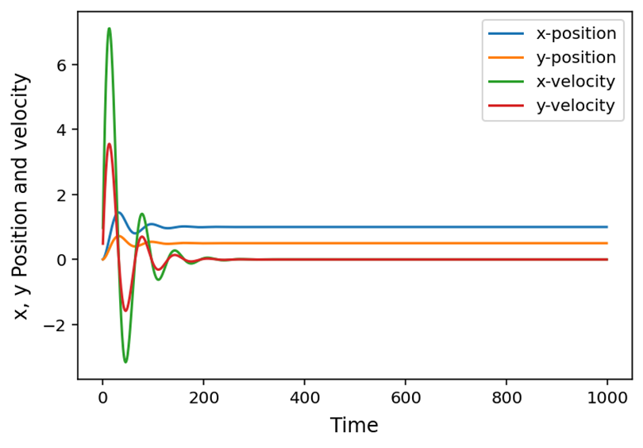

b)

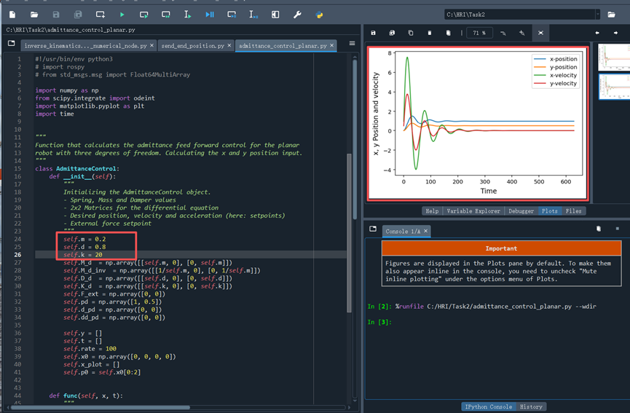

Inertia (M_{d}): Acts like mass. A larger inertia makes the system feel “heavier” like slower response, smaller acceleration, and smoother motion. A smaller inertia gives faster reaction but can cause oscillations.
- Damping (B_{d}): Controls oscillations and overshoot. Increasing damping reduces oscillation and overshoot but slows the response. Too little damping causes underdamped vibration.
- Stiffness (K_{d}): Defines the “spring” behavior. A higher stiffness leads to faster convergence and smaller steady-state error but may increase overshoot. A smaller stiffness makes the system more compliant and results in a larger steady-state displacement.
In short:
M_{d​} controls responsiveness,
B_{d}​ controls smoothness,
K_{d}​ controls compliance and steady-state offset.

c)

For a constant external force (step input), the system behaves like a second-order response (defined by M_{d} B_{d} K_{d}​ ​) and reaches a steady-state displacement（A larger stiffness reduces the steady-state offset.）
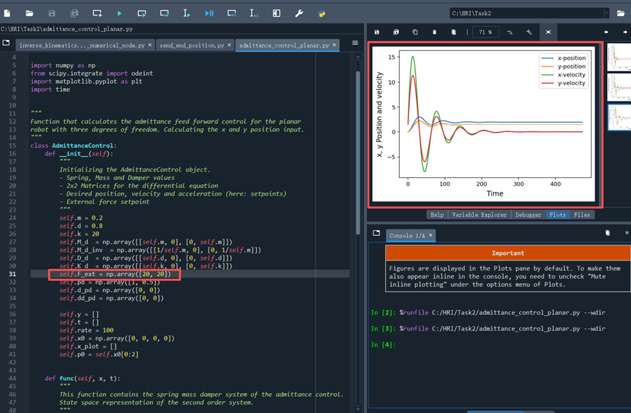

d)

odeint is used because the admittance control is a time-dependent differential equation.
An algebraic solution only works for static cases, while odeint can integrate the dynamics over time for any external force or parameter change.

